## How to build

* Pre-requisition

Maven and JDK are required.

Maven 3.2.1 and JDK 1.7 were used in development.

* Steps (windows)

1. Go to the project folder
2. Run following command to get war

*mvn package*

the following is a snapshot for reference

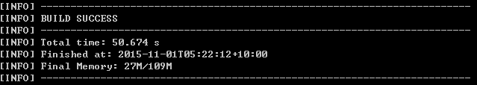

And a war file will be generated under folder “target”, which looks like weather-0.0.1-SNAPSHOT.war.

## How to deploy and use

* Pre-requisition

It can be run directly since it’s a war with embedded web server. Or it can be deployed on Tomcat.

In latter case, Tomcat is required (my test is based on Tomcat 7.0.59). Otherwise, only JDK is required.

* Steps (Windows)

Run it directly

1. Download weather-0.0.1-SNAPSHOT.war
2. Open a command window and execute the following command

java jar weather-0.0.1-SNAPSHOT.war

1. Visit <http://[server]:[port>]

Deploy and run based on Tomcat

1. Copy weather-0.0.1-SNAPSHOT.war (which is copied from target folder) to [Tomcat-Home]\webapps, and change its name to weather.war.
2. Start Tomcat server
3. Visit <http://[tomcat-server]:[port]/weather/>

Some snapshots are as follows for reference:

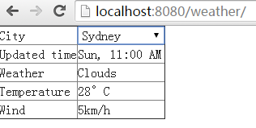

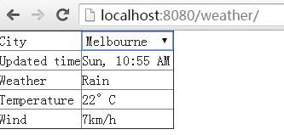

## How to run frontend e2e test cases

* Pre-requisition

Node.JS (npm) and browsers to test need to be installed in advance. Please refer to <https://github.com/angular/angular-seed> for further information.

Node.JS v0.12.6 and Chrome v45 were used in development

* Steps (windows)

1. Deploy the generated war and start tomcat (refer to “How to deploy and use”)
2. Go to the subfolder “ngclient” under project folder
3. Check and refine “e2e-tests\protractor.conf.js” to make sure server URL and browsers required to test are set correctly
4. Open a console and run the following command in “nglcient” directory

*npm run protractor*

A log file is attached as follows for reference, which was generated in development.

